1. Partner need to provide the following information to create a new partner account
2. Company name
3. Sub-domain name

Note : The users of sites which create by partner will use the following URL to login into the platform:

*https:// {subdomain}.platform.comm100.com*

1. Website of their company
2. Contact Name
3. Contact Email ( we will use this email to create a partner account)
4. Contact Number
5. Contact Title
6. Branding Name (If partner does not provide, the default branding name is Comm100)
7. Product Name (if partner does not provide, the default product name is Comm100 Live Chat)
8. Favicon file

file type: icon

Max file size : 100kb

1. Logo file

file type: gif, jpg,jpeg, png, bmp,svg

Max file size: 100kb

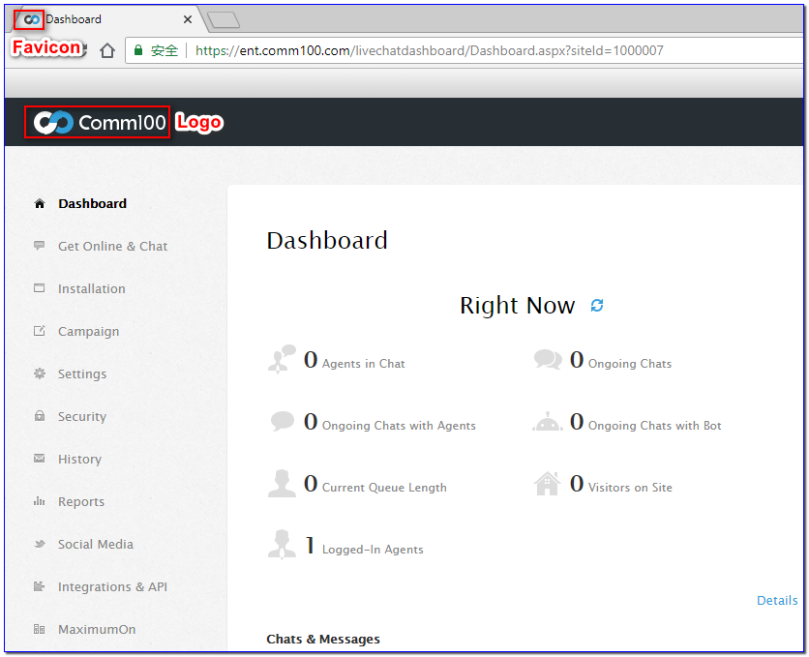

1. If the partner want to customize the display style of our product, they must tell us the detail requirement. In principle, only simple display style changes such as theme colors, fonts, menu styles, functional display images, etc. are acceptable.

We suggest that partners take a look at our products firstly and then decide how to modify the display styles. It is better to provide some design sketch to help us to understand the requirement.